Course code:
Student Name:

ME 4160 Controls Lab 3

“Effect of Gain on Settling Time in Open-Loop and Closed-Loop System”

Abstract:
The purpose of this experiment is to become familiar with the both types of control system (open-loop system and closed-loop system) And, observe and compare the effect of gain on settling time for both types of systems.

Introduction:

Open-loop system: is a type of control system in which the output has no effect on the control action of the input signal is called an Open-loop system. An open-loop system is defined by the fact that the output signal or condition is neither measured nor “fed back” for comparison with the input signal or system set point. Examples of the open loop control systems include washing machines, light switches, gas ovens, etc. A washing machine is an example of an open loop control system.

Closed -loop system: A closed loop control system is a set of mechanical or electronic devices that automatically regulates a process variable to a desired state or set point without human interaction. Closed loop control systems contrast with open loop control systems, which require manual input.

- An open loop control system acts completely based on input and the output has no effect on the control action.
- A closed loop control system considers the current output and alters it to the desired condition.
- In closed loop control systems stability is a major issue.

Procedure:
1-a Open-loop System

- Connect the wires for an open-loop system as shown in Figure 1.

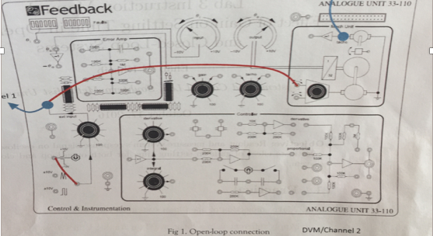
Figure 1: Open Loop Connection

- Apply different values of gain p3 on analog unit (20%, 40%, 80%, 100) and +10V unit input voltage. Then measure steady state voltage and motor RPM using DVM port.

- Then took measurements by looking at the oscilloscope and the volt and rpm outputs from the mechanical unit. After this, plot the response of the motor’s steady-state output voltage with respect to different gain values, for both system as well in the same plots.

1-b Closed -loop system

- Connect the wires for a closed-loop system as shown in Figure 2.

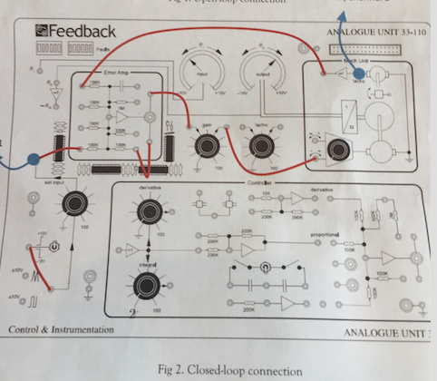
Figure 2: Connections for Closed Loop

- For closed-loop system repeat the same above system but for system set P3= 100% and P1 at different Values (20% 40% 80% 100%).

- Then took measurements by looking at the oscilloscope and the volt and rpm outputs from the mechanical unit. After this, plot the response of the motor’s steady-state output voltage with respect to different gain values, for both system as well in the same plots.

Experimental Data:
Table 1: Open Loop System
Gain = P3/P1
- For 20% Gain

%Vfinal | Time[ms] | V_{out}[V]
10% | 140 | 0.13
50% | 340 | 0.05
90% | 1.47 | 1.17
100% | 1.86 | 1.30
settling | 1.81 | 1.274

- For 40% Gain

%Vfinal | Time[ms] | V_{out}[V]
10% | 60 | 0.33
50% | 320 | 1.67
90% | 1.005 | 3.01
100% | 1.75 | 3.34
settling | 1.705 | 3.27

- For 80% Gain

%Vfinal | Time[ms] | V_{out}[V]
10% | 60 | 0.723
50% | 340 us | 3.62
90% | 1.005 | 6.51
100% | 1.76 | 7.23
settling | 1.72 | 7.08

- For 100% Gain

%Vfinal | Time[ms] | V_{out}[V]
10% | 100 | 0.73
50% | 280 | 3.65
90% | 660 | 6.57
100% | 1.37 | 7.30
settling | 1.2 | 7.15
Experimental Data:
Table 2: Closed-Loop SystemGain = P3/P1
- For 20% Gain

%Vfinal | Time[ms] | V_{out}[V]
10% | 140 | 0.046
50% | 360 | 0.23
90% | 1.10 | 0.414
100% | 1.42 | 3.34
settling | 1.215 | 0.45

- For 40% Gain

%Vfinal | Time[ms] | V_{out}[V]
10% | 80 | 0.117
50% | 280 | 0.585
90% | 720 | 1.053
100% | 1.12 | 1.17
settling

- For 80% Gain

%Vfinal | Time[ms] | V_{out}[V]
10% | 40 | 0.36
50% | 220 | 1.34
90% | 620 | 3.32
100% | 660 | 3.64
settling | 8.42 | 3.55

- For 100% Gain

%Vfinal | Time[ms] | V_{out}[V]
10% | 40 | 0.47
50% | 180 | 2.38
90% | 520 | 4.293
100% | 800 | 4.77
settling | 784 | 4.67

Calculation:
For 20%
$$0.0462V×11.428=0.52 rpm$$
For 40%
$$0.117V×11.428\frac{rpm}{V}=1.337 rpm$$
For 80%
$$0.36V×11.428\frac{rpm}{V}=4.15405 rpm$$
For 100%
$$0.4732V×11.428\frac{rpm}{V}=5.37369 rpm$$
Results:
In the results section, we will see the effect of the gain on the settling time for open and closed loop system. I have plot the response of the motor for each gain position by taking at least 5 data points (10%, 50%, 90%, 100%, settling time) for each response curve and converting the motor to rpm. To convert the voltage output from volts to RPM, we use the K value from our Lab 1 and the following equation:

$$ω=KV_{out}$$

The K value used for lab3 is 11.428 rpm/V.
- In Graph 1 I have shown the relationship between the motor response and the percent of the steady state for the open loop for each of the P3 gain positions.

Graph 1. Open Loop motor response (RPM)

- In Graph-2 I have shown the relationship between the motor response and the percent of the steady state for the closed loop for each of the P3 gain positions.

Graph 2. Closed Loop motor response (RPM)

- In Graph-3 I have shown the difference between open loop and closed loop for gain as it affects the settling time.

Graph 3. Open vs Closed loop gain effects on settling time 10%

- Graph 4 shows the difference between open loop and closed loop for gain as it affects the settling time.
Graph 4. Open vs Closed loop gain effects on settling time 50%

Graph 5 shows the difference between open loop and closed loop for gain as it affects the settling time.

Graph 5. Open vs Closed loop gain effects on settling time 90%

- Graph 6 shows the difference between open loop and closed loop for gain as it affects the settling time.

Graph 6. Open vs Closed loop gain effects on settling time 100%
.

- Graph 7 shows the difference between open loop and closed loop for gain as it affects the settling time.
Graph 7. Open vs Closed loop gain effects on settling time 98%

Discussion and Analysis:

As we can see that open loop’s graph (3,4,5,6,7) showed a more diverse settling time because open loop has no feedback. In contrast, closed loop has a more constant settling time because it has feedback. While both systems have varying settling times, the closed loop has the more constant settling time, as expected. By viewing graphs, we can say that as the gain increases there is not a purely positive or purely negative correlation with the settling time values. However, for the closed loop system, as the gain increases, the settling time seems to either remain constant or slowly decrease.

Conclusion:
After this experiment I have understand that how the effect of Gain on settling in time Open loop and Closed loop.

